Name:

EarthShip Project Rubrics

Stage 1: Research Rubric

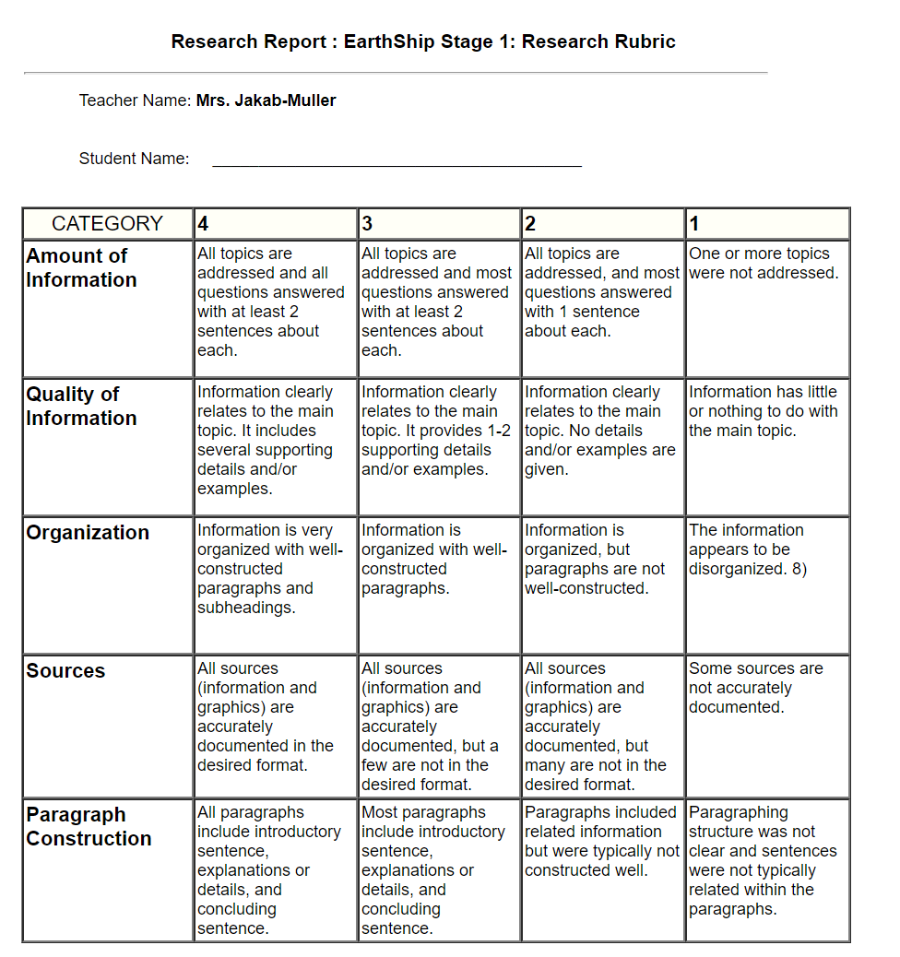

Rubric Score:

Name:

EarthShip Project Rubrics

Stage 2: Planning Rubric

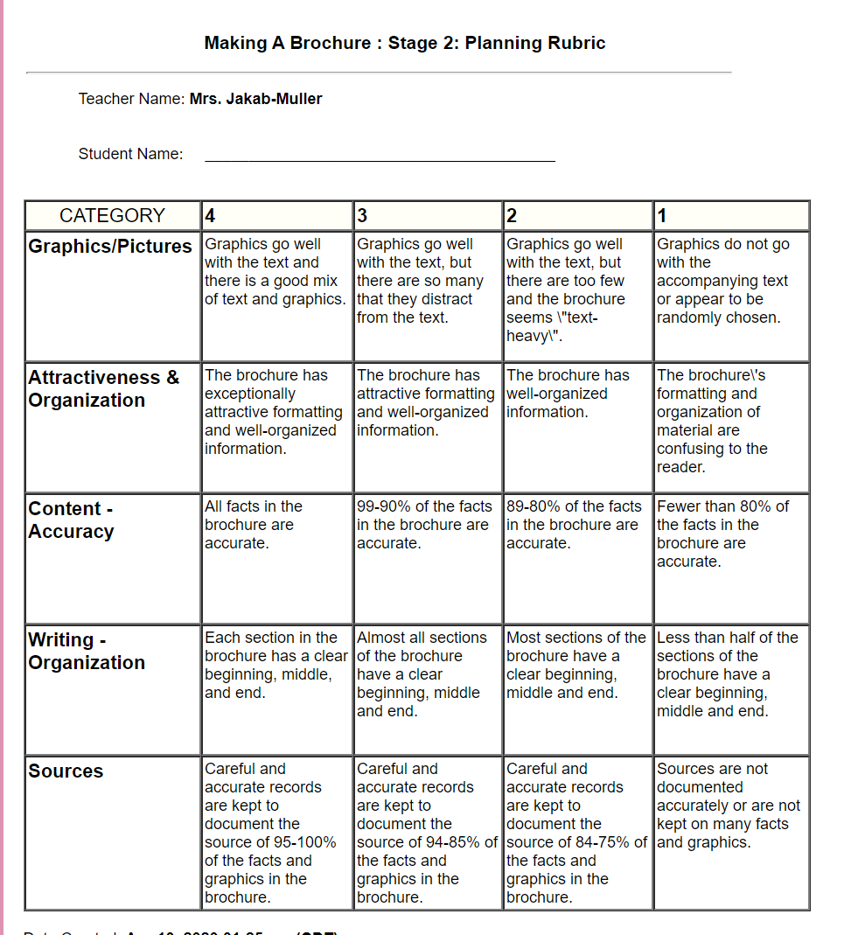

Rubric Score:

Name:

EarthShip Project Rubrics

Stage 3: Presentation

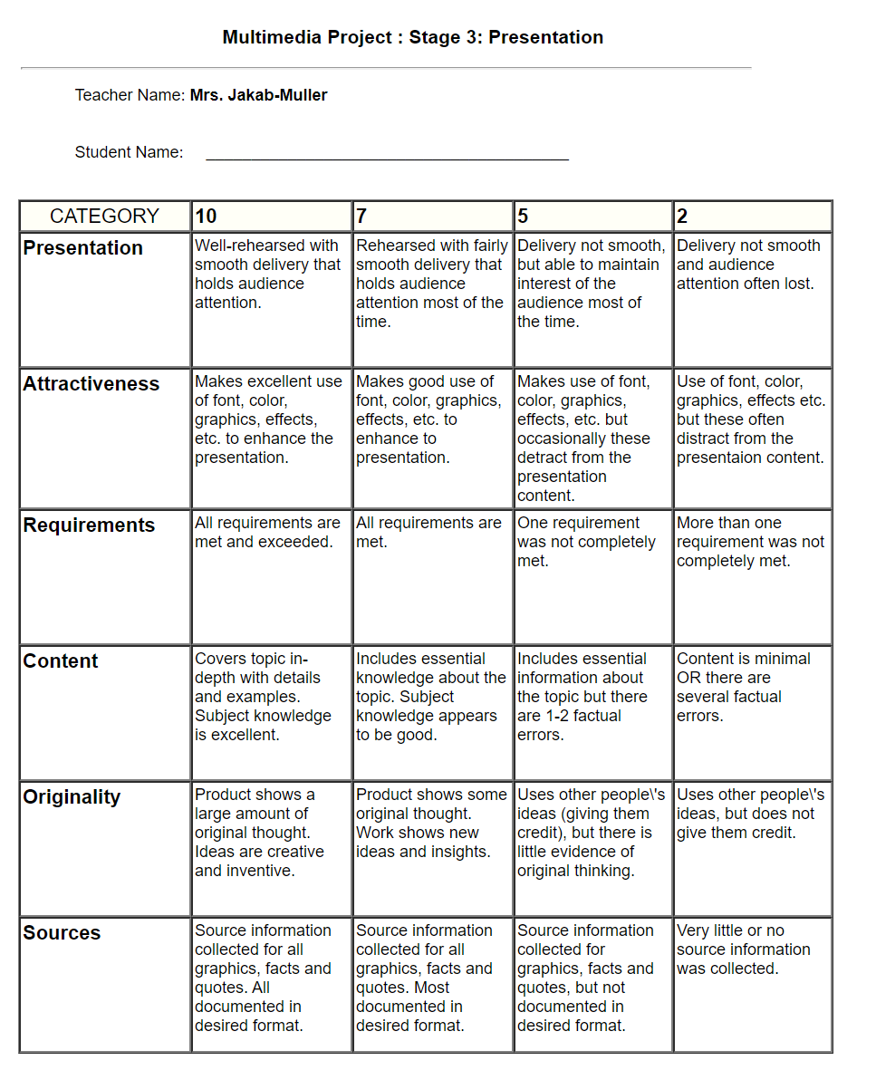

Rubric Score:

Name:

EarthShip Project Rubrics

Total Project Score Sheet:

|  |  |
| --- | --- |
| Stage 1: Research |  |
| Stage 2: Planning |  |
| Stage 3: Presentation |  |
| Total Project Score |  |